Please complete the following table with what you believe to be the percentage that each member of your team, including yourself, has contributed to these delivery cycles. They should add up to 100%
Student ID | Me and Team member name | Contribution %
31291252 | XiaoHui Ding | 27%
31526152 | HaoRong Ren | 27%
30912148 | Mihir Raj Bhanushali | 23%
30497426 | Manyan Wen | 23%
 | Total contribution | 100%

Please detail YOUR TEAM’s specific contribution to your implementation below:

1. Overview
Please describe how team works in general, any conflict or any way you approach the conflict:
We used to check our progress through Trello, where we assigned our personal task and its due date. For most of the problems, we discuss and solve them in the tutorial and in the MSTEAMS after class. In addition, we also schedule regular scaled meetings in the process. When any one of us had a problem coding, the rest of the team tried to help us as much as possible.

2. Classes and functions done by each member of your team
(Please write out all classes and functions names by each member of your team)

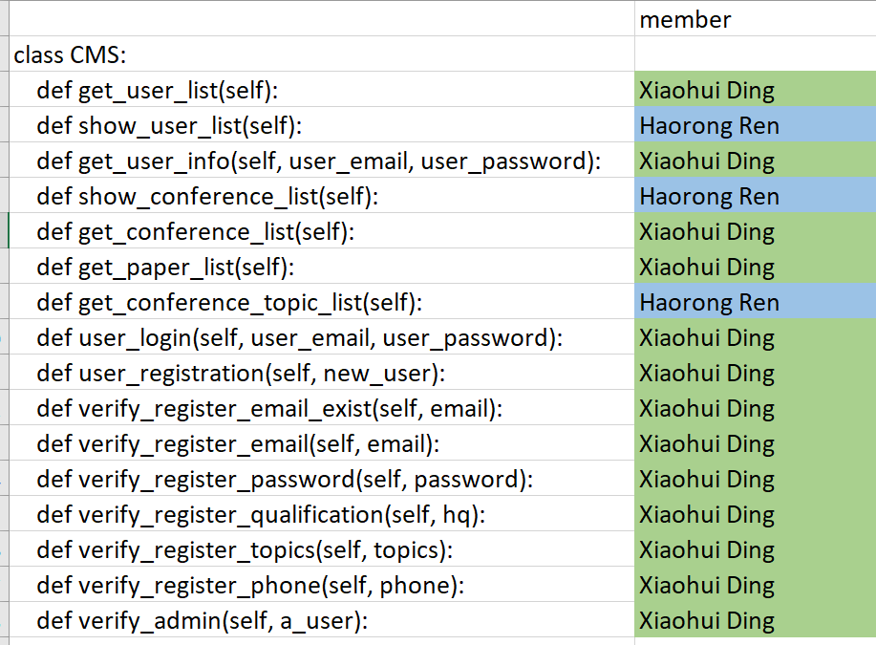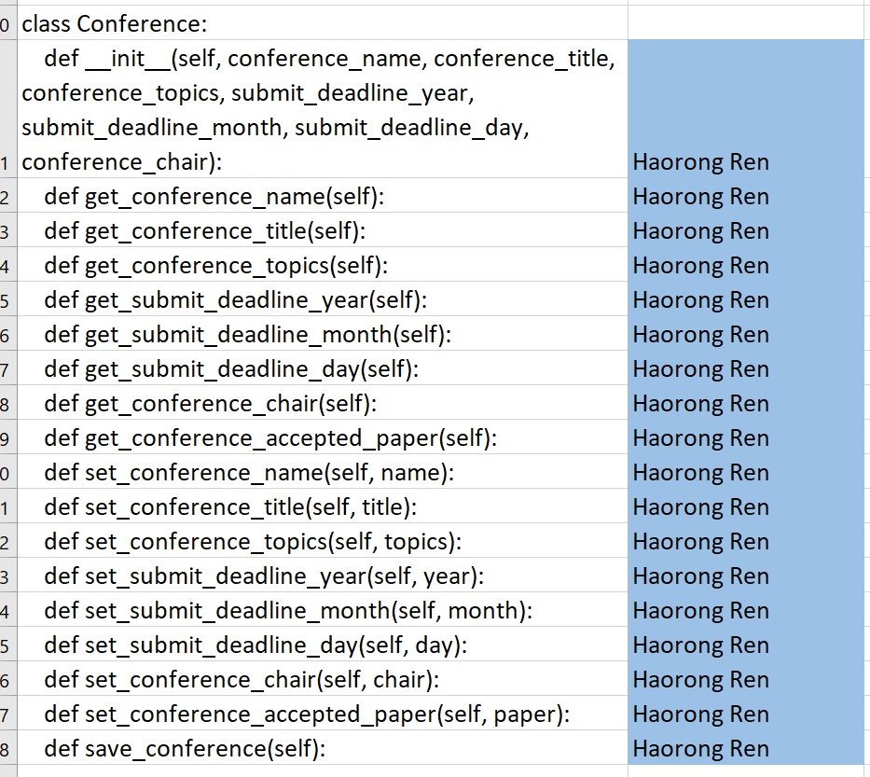

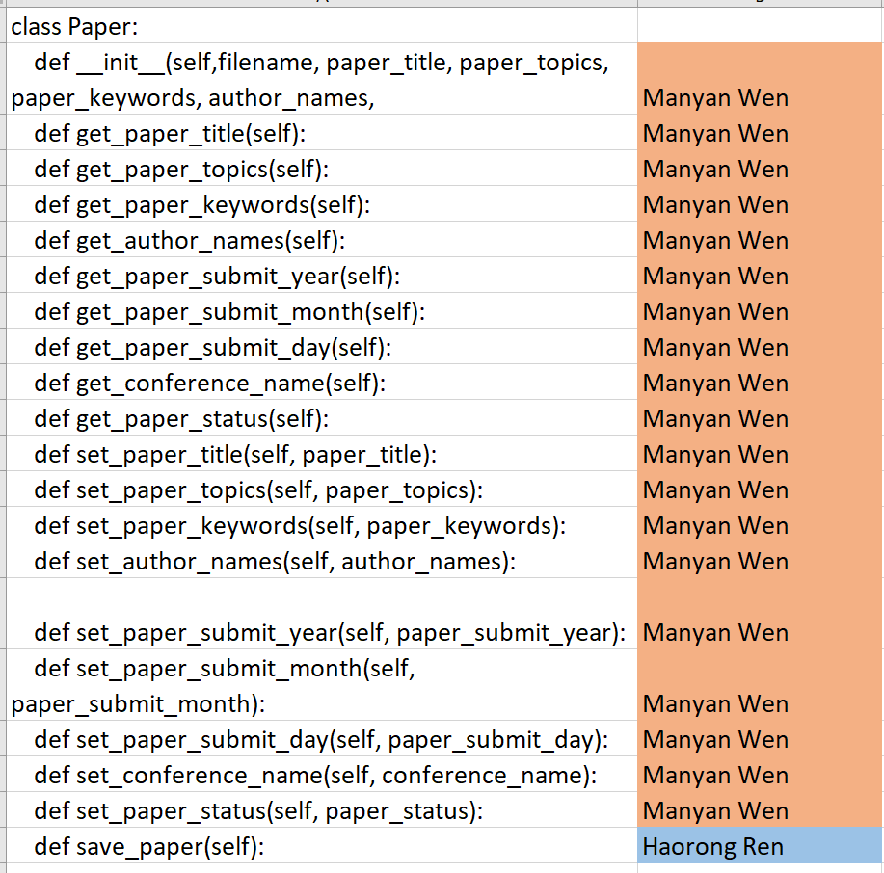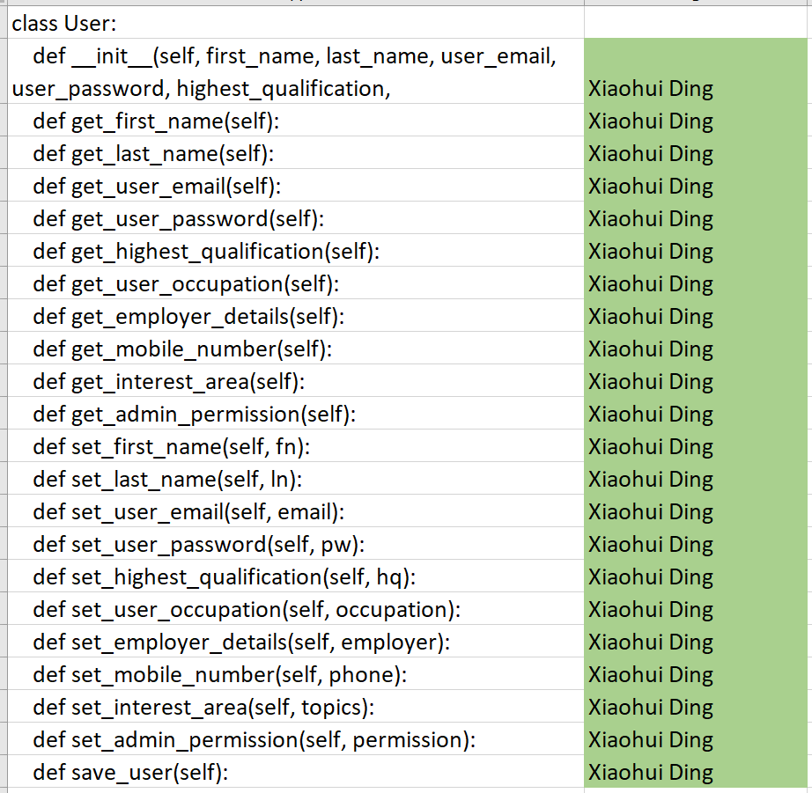
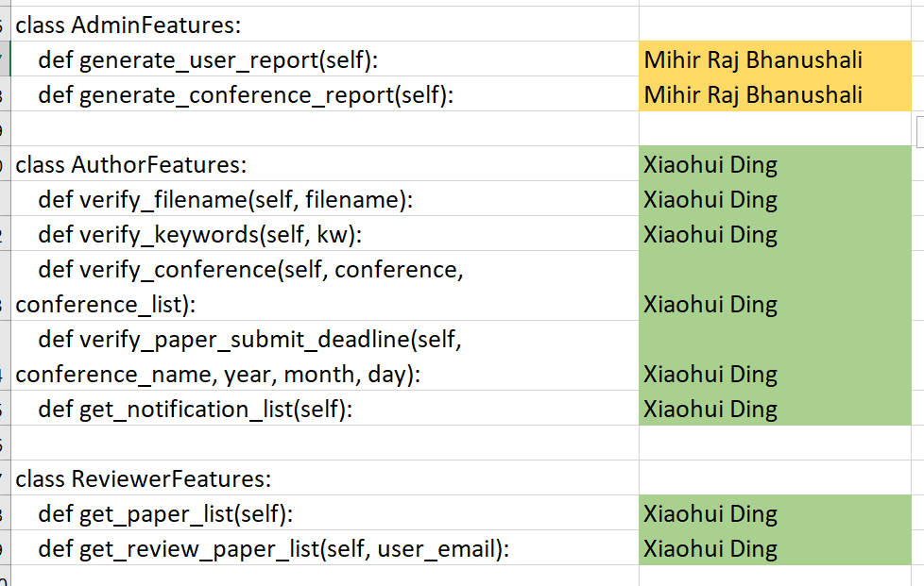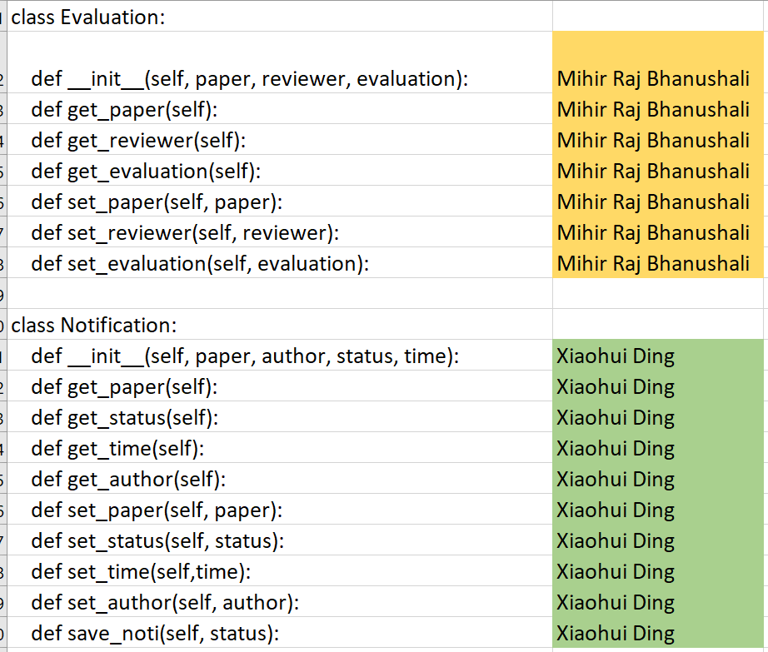
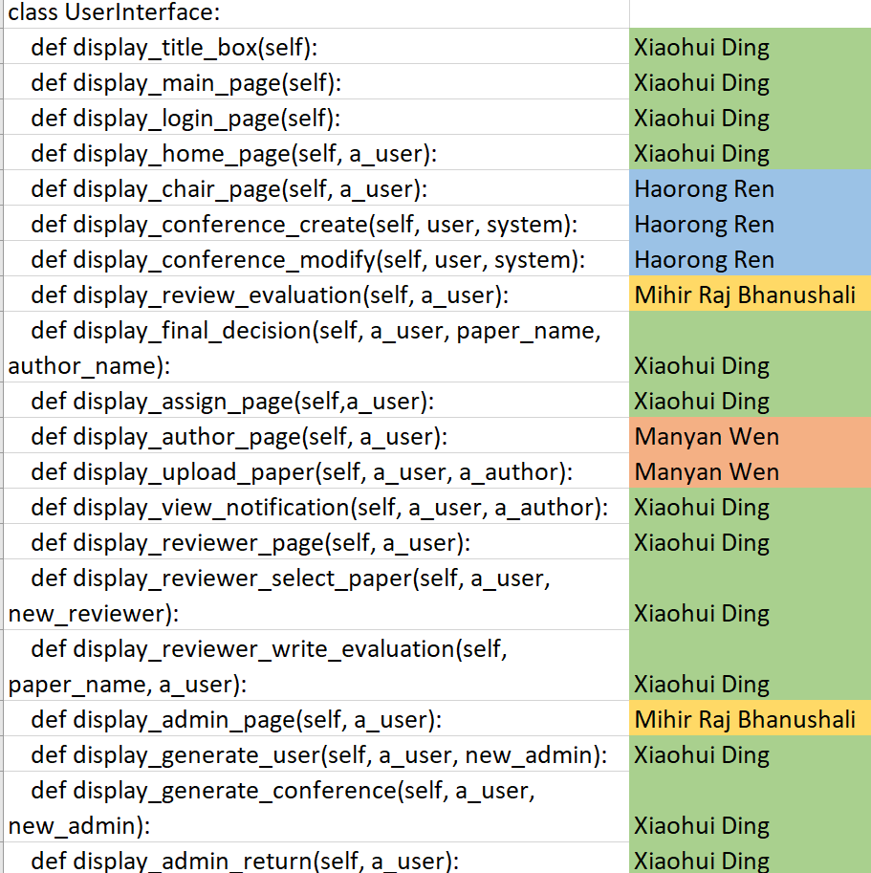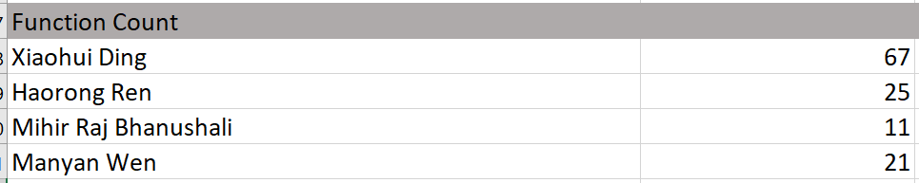

Disclaimer:
The function count and commit count cannot directly present our contribution on code. We suggest using pure code check which is a feature of GIT to check our whole contribution.

3. Have you participate in writing user instructions? If you have, please share which section you have done and how much time you spent working on this in total

Mihir Raj Bhanushali: Most part of user instructions. Time spent: 7 hours.
Xiaohui Ding: Modification of some details. Time spent: 2 hours.
Manyan Wen: Modification of some details. Time spent: 1 hours.
Haorong Ren: Modification of some details. Time spent: 1 hours.

4. Other (anything not covered in the previous sections)

